# 

# TASK 1: Review of Existing IVR Architecture & Capabilities

1. Introduction to Traditional IVR Systems

## 1.1 What is an IVR System

An Interactive Voice Response (IVR) system is an automated communication system that interacts with callers through a telephone network to provide information or execute predefined services without human intervention. IVR systems are designed to receive incoming calls, interpret user input, and respond with appropriate audio prompts or service actions. The interaction typically follows a structured flow that guides users step by step

Core functional elements of a traditional IVR system include:

* Call answering and session management
* Voice prompt playback (pre-recorded or synthesized)
* Input collection using keypad (DTMF) or limited speech recognition
* Execution of predefined business rules
* Integration with backend services for data retrieval

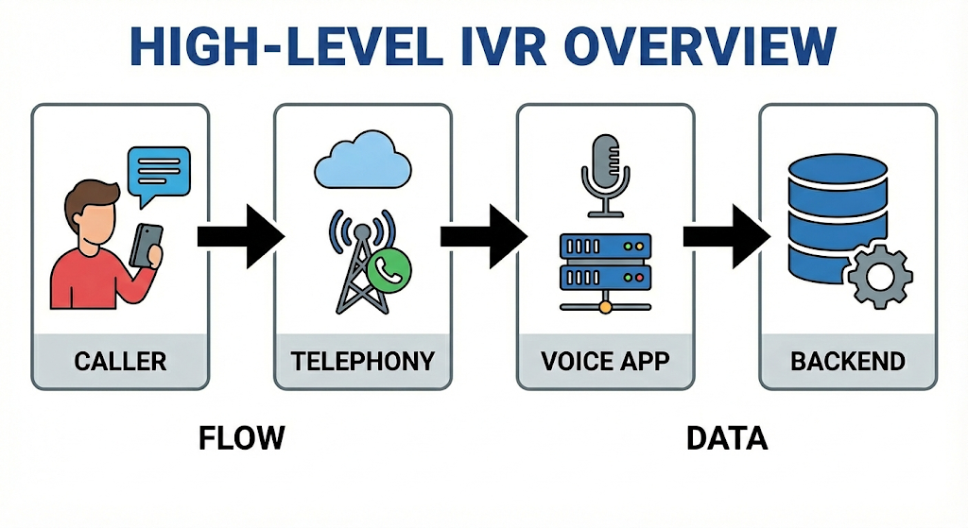

## 1.2 Role of IVRs in Large-Scale Public Platforms

IVR systems are extensively used in large-scale public and enterprise platforms due to their ability to handle massive call volumes efficiently. These platforms require uninterrupted service availability and standardized responses.

Major domains where IVRs are widely deployed include:

* **Railway services**: PNR status, train schedules, live train running status
* **Banking systems**: account balance, transaction confirmation, card services
* **Government services**: citizen helplines, scheme information, grievance support

In railway platforms such as **IRCTC**, IVRs serve millions of passengers by providing essential travel-related information. IVRs help reduce call center workload, ensure 24×7 service availability, and maintain consistency in information delivery across diverse user groups.

### ****1**.3 Why Traditional IVRs Were Designed as Menu-Based Systems**

Traditional IVR systems were predominantly designed as menu-based systems because of the technological limitations and operational priorities present during their initial adoption. Early IVR implementations relied on keypad-based user inputs using Dual Tone Multi Frequency (DTMF) signals rather than natural language interaction.

The key reasons for adopting menu-based designs include:

* Speech recognition technology was immature and unreliable, especially in noisy telephony environments
* High variability in accents, dialects, and languages made accurate voice recognition difficult
* Menu-based flows provided deterministic and predictable interaction paths
* Easier testing, validation, and regulatory compliance
* Strong compatibility with legacy telephony infrastructure

Menu-driven IVRs allowed system designers to define structured decision trees where each numeric input led to a specific system response. This made IVR behavior transparent, auditable, and easier to maintain. However, this approach also resulted in limitations such as deep menu hierarchies, longer call durations, and limited personalization.

Despite these drawbacks, menu-based IVRs were widely adopted because they offered reliability, scalability, and operational control, which were essential for large public service platforms.

**2. Architecture of Traditional IVR Systems**

Traditional IVR systems are built on a layered architecture that connects the public telephony network with backend enterprise systems. The architecture is designed to be robust, deterministic, and scalable, ensuring reliable service delivery even under heavy call volumes. Each layer of the architecture has a well-defined role, enabling clear separation of concerns and easier maintenance.

## 2.1 Traditional IVR Call Flow

A typical call flow in a traditional IVR system proceeds as follows:

1. A user places a call to a service number.
2. The call is received by the telephony gateway.
3. The call is routed to the IVR application server.
4. The IVR plays a welcome prompt and menu options.
5. The user provides input using keypad (DTMF) or limited speech.
6. Based on the input, the IVR executes predefined logic.
7. If required, the IVR fetches data from backend systems.
8. The system responds with audio output or routes the call further.

This flow is **linear and deterministic**, meaning every possible path is defined in advance

## 2.2 Core Components of a Traditional IVR System

**2.2.1 Telephony Gateway**

The telephony gateway is responsible for interfacing with the public switched telephone network (PSTN). It manages call setup, call teardown, audio transmission, and signal handling.

Key responsibilities include: Receiving incoming calls, Receiving incoming calls, Managing call sessions, Converting voice signals into a format usable by the IVR application, Supporting DTMF input detection

This component ensures that IVR systems can interact seamlessly with traditional telephone networks.

**2.2.2 Voice Application Server**

The voice application server hosts the IVR logic and controls the call flow. It determines which prompts to play, how to process user inputs, and what actions to take based on predefined rules.

Its main functions include: Executing IVR scripts, Managing menus and navigation logic, Managing menus and navigation logic, Triggering backend service calls, Handling user input validation

**2.2.3 Backend Systems**

Backend systems provide the actual business data required by the IVR. These systems may include databases, enterprise applications, or legacy information systems.

Examples of backend systems include:

* Passenger and booking databases
* Transaction processing systems
* Information management services

## 2.3 Role of VoiceXML (VXML) in Traditional IVRs

VoiceXML (VXML) is a mark-up language specifically designed to define voice-based user interfaces. It plays a central role in traditional IVR implementations.

In a traditional IVR:

* VXML defines prompts, menus, and grammar rules
* User inputs are captured and processed using VXML tags
* Call flow transitions are controlled through VXML logic

VXML enables separation of **presentation (voice prompts)** from **business logic**, making IVR applications easier to update and manage without changing backend systems.

## 2.4 Architectural Characteristics of Traditional IVRs

Key architectural characteristics include:

* Centralized control of call flows
* Tight coupling between IVR logic and backend systems
* Static and predefined interaction paths
* Limited flexibility for dynamic or conversational behavior

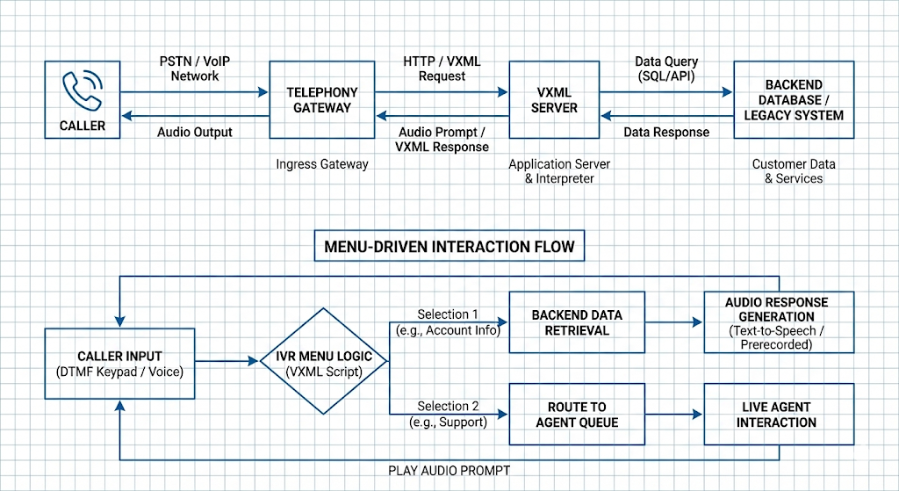

**3. Technologies Used in Traditional IVR Systems**

## 3.1 VoiceXML (VXML)

VoiceXML (VXML) is the core technology used to design and control traditional IVR applications. It is a markup language specifically created for voice-based user interaction, similar in concept to how HTML is used for web interfaces.

Key characteristics of VoiceXML include:

* Definition of voice prompts and audio playback
* Menu creation and navigation logic
* Grammar rules for accepting user input
* Control over call flow transitions and error handling

In traditional IVR systems, the voice application server interprets VXML scripts to determine how the call progresses. Each menu option, prompt, and backend interaction is predefined within the VXML logic. This approach allows IVR developers to design structured and deterministic call flows that are easy to test and maintain.

## 3.2 DTMF vs Speech-Based Inputs

Traditional IVRs primarily rely on **DTMF (Dual Tone Multi Frequency)** inputs, where users respond by pressing numeric keys on their phone keypad. This method is widely used due to its simplicity and reliability.

**DTMF-based input characteristics:**

* High accuracy with minimal interpretation errors
* Strong compatibility with all telephone devices
* Predictable and deterministic behavior
* Low processing overhead

Due to these limitations, most public service IVRs continued to favor DTMF-based interaction as the primary input mechanism.

## 3.3 Backend APIs and Databases

Traditional IVR systems are tightly integrated with backend enterprise systems to fetch and process real-time data. These backend systems store business-critical information required to respond to user queries.

Common backend integrations include:

* Relational databases for storing user and transaction data
* Legacy enterprise systems accessed through APIs
* Middleware services for data transformation and validation

In railway platforms such as **IRCTC**, backend systems provide data related to:

* PNR status and passenger details
* Train schedules and running status
* Ticket booking and cancellation information

**3.4 Deployment Models of Traditional IVRs**

Traditional IVR systems are typically deployed using one of the following models, depending on organizational requirements:

**On-Premises Deployment**

* IVR hardware and software are hosted within the organization’s data center
* Greater control over security and compliance
* Higher infrastructure and maintenance costs

**Hosted Deployment**

* IVR services are provided by third-party vendors
* Reduced infrastructure management
* Limited customization and control

**Hybrid Deployment**

* Combination of on-premises IVR logic with externally hosted services
* Common in large public platforms requiring both control and scalability

Public sector and mission-critical platforms often prefer on-premises or hybrid models to meet regulatory, data security, and availability requirements.

**4. Capabilities of Existing IVR Implementations**

Traditional IVR systems, despite their limitations, provide a well-defined set of capabilities that make them suitable for large-scale and mission-critical public services. These capabilities are designed to ensure reliability, consistency, and efficient handling of high call volumes.

## 4.1 Call Routing and Call Handling

One of the primary capabilities of traditional IVR systems is automated call routing. IVRs can analyse user input and route calls to appropriate menus, services, or human agents.

Key aspects include:

* Automatic answering and session management for incoming calls
* Routing calls based on user-selected options
* Transfer of calls to live agents when automation cannot resolve the query
* Load distribution across call center agents during peak hours

## 4.2 Menu-Based Navigation

Traditional IVRs are built around hierarchical, menu-driven navigation structures. Users interact with the system by selecting numeric options presented through voice prompts.

Capabilities of menu navigation include:

* Structured and predictable interaction flows
* Clear separation of services into logical menus
* Step-by-step guidance for users
* Deterministic outcomes based on user choices

## 4.3 Backend Data Fetch and Transaction Support

Existing IVR systems are capable of fetching real-time or near-real-time data from backend enterprise systems. This allows IVRs to provide up-to-date information to callers.

Typical backend-driven capabilities include:

* Fetching customer or passenger records
* Retrieving transaction or booking status
* Providing service availability or schedule information

## 4.4 Multilingual Language Support

To serve diverse user populations, traditional IVR systems often support multiple regional and national languages. Language selection is typically offered as an initial menu option.

Language-related capabilities include:

* Pre-recorded prompts in multiple languages
* Language-specific menu navigation
* Consistent service delivery across different linguistic groups

## 4.5 Error Handling and Fallback Mechanisms

Traditional IVRs incorporate basic error-handling mechanisms to manage invalid or unexpected user inputs.

Common error-handling features include:

* Repeating prompts when invalid input is detected
* Redirecting users to previous menus
* Providing fallback options such as agent transfer

These mechanisms ensure call continuity but lack intelligent understanding of user intent.

**5. How Traditional IVRs Use Modern Platforms**

## 5.1 Overview of Modern Communication and Conversational Platforms

Modern platforms provide cloud-based communication, speech processing, and conversational intelligence capabilities that extend the functionality of traditional IVRs. Instead of replacing legacy systems entirely, these platforms are often used as **enablers** or **support layers**.

Common modern platforms relevant to IVR systems include:

* **Twilio** for programmable voice and call handling
* **Azure Communication Services** for telephony, voice, and messaging
* **BAP (Bot Application Platform)**–style conversational services for dialog and intent handling

Traditional IVRs typically interact with these platforms through APIs rather than migrating fully to them.

## 5.2 Use of Twilio in Traditional IVR Systems (Theoretical Overview)

Twilio is often used as a **cloud telephony gateway** rather than a complete IVR replacement. In traditional IVR modernization scenarios, Twilio performs limited but critical roles.

Typical usage patterns include:

* Handling inbound and outbound calls using cloud infrastructure
* Replacing physical telephony gateways
* Routing calls to existing IVR logic hosted elsewhere
* Executing simple IVR flows using Twilio’s markup language

In such cases, the core IVR logic (menus, backend calls, decision trees) still resides in legacy systems. Twilio mainly acts as a **communication interface**, not as the decision-making engine.

Limitations in traditional reuse:

* Existing VXML logic cannot be reused directly without adaptation
* Deep menu-based flows remain unchanged
* Conversational intelligence is minimal unless additional services are integrated

## 5.3 Use of ACS and BAP in Traditional IVR Contexts (Conceptual)

Azure Communication Services (ACS) and BAP-style conversational platforms represent a more **enterprise-aligned modernization path**, especially for large public systems.

**Role of ACS**

ACS provides core communication capabilities such as:

* Voice call handling
* Speech-to-text (STT)
* Text-to-speech (TTS)
* Call control and session management

In traditional IVR integration, ACS is commonly used to:

* Replace legacy telephony infrastructure
* Enable scalable cloud-based call handling
* Provide speech processing services

**Role of BAP (Bot Application Platform)**

BAP-style platforms handle:

* Intent detection
* Context management
* Dialog orchestration
* Conversational flow control

Instead of menu trees, BAP enables **intent-driven interaction**, allowing users to speak naturally rather than follow rigid menus.

## 5.4 Limitations in Legacy Reuse

While modern platforms provide powerful capabilities, traditional IVRs face several reuse limitations:

* VXML scripts are not directly compatible with conversational platforms
* Menu-based logic does not map naturally to intent-based models
* Context handling is limited or absent in legacy systems
* Backend integrations are tightly coupled to IVR flows
* Any significant change requires modification of legacy code

These limitations make direct modernization difficult without an intermediate integration layer.

## 5.5 IRCTC IVR Perspective

In large public systems like **IRCTC**, it is unlikely that the entire IVR infrastructure is built on cloud platforms like Twilio or ACS. Instead, the more realistic scenario involves:

* Legacy IVR systems handling core call logic
* Backend railway systems providing PNR, train, and booking data
* Selective use of modern platforms for scalability or speech services
* Strong dependency on deterministic and stable call flows

This cautious integration approach ensures system reliability while gradually enabling modernization.

**6. IRCTC IVR: Architecture & Implementation**

**6.1 Overview of IRCTC IVR Services**

The Interactive Voice Response (IVR) system used within the Indian railway ecosystem acts as a critical public-facing communication channel for passenger information and enquiry services. Platforms such as IRCTC serve millions of passengers daily, many of whom depend on IVR systems for accessing railway information without relying on internet connectivity or smartphones.

The IRCTC IVR primarily functions as an information dissemination and enquiry platform rather than a fully transactional system. It is designed to cater to a broad and diverse user base, including passengers with limited digitalliteracy, basic mobile devices, or accessibility constraints. The system emphasizes simplicity, reliability, and inclusivity.

Common services offered through the IRCTC IVR include:

* PNR status enquiry
* Train running status
* Train schedules and seat availability
* General railway and travel-related guidance

These services are delivered through automated voice prompts using predefined interaction flows to ensure consistency and correctness.

**6.2 Typical IRCTC IVR Call Flow**

The traditional IRCTC IVR follows a menu-driven and deterministic call flow, which prioritizes predictability and operational reliability over conversational flexibility. Each call interaction progresses through clearly defined stages.

A typical IRCTC IVR call flow includes:

* Call initiation by the user to a railway enquiry number
* Initial language selection prompt
* Presentation of service menus (e.g., PNR enquiry, train status)
* User input through keypad-based DTMF signals
* Backend request generation based on selected menu option
* Retrieval of data from railway systems
* Audio response playback to the caller
* Call termination or redirection to the main menu

This structured approach ensures controlled execution paths and minimizes ambiguity, making it suitable for large-scale public services.

**6.3 Backend Integrations in IRCTC IVR**

The IRCTC IVR system is tightly integrated with multiple backend railway information systems responsible for storing and managing real-time operational and passenger data. These backend systems form the backbone of all IVR responses.

Key backend integrations include:

* Passenger Name Record (PNR) databases
* Train scheduling and running status systems
* Reservation and ticketing databases
* Centralized railway information management systems

The IVR acts as a consumer of these backend services by sending structured requests and converting received responses into voice-based outputs. While this tight coupling enables accurate and near real-time information delivery, it also increases dependency on backend availability and performance.

**6.4 Architectural Characteristics of IRCTC IVR**

The architectural design of the IRCTC IVR reflects characteristics commonly found in large-scale, public-sector IVR deployments. The primary focus is on stability, scalability, and uninterrupted service delivery.

Key architectural characteristics include:

* Centralized control of IVR logic
* Extensive use of VoiceXML or equivalent scripting technologies
* Menu-based navigation using DTMF inputs
* Minimal conversational or contextual intelligence
* Strong emphasis on uptime, fault tolerance, and predictability

This architecture is optimized for handling massive call volumes efficiently, often at the expense of flexibility and user experience enhancement.

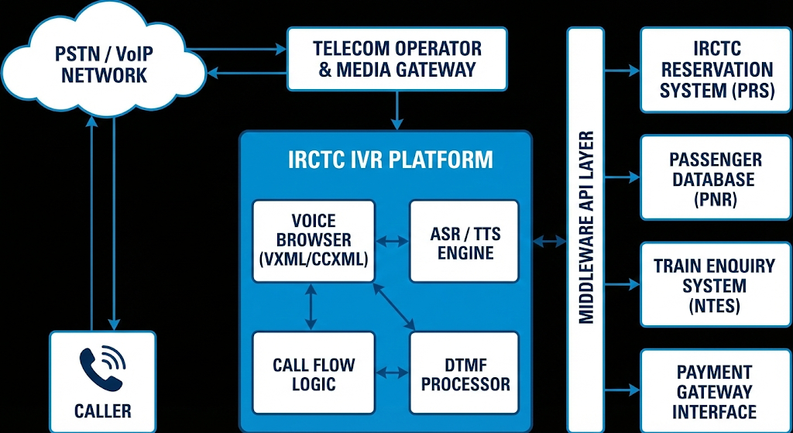

*IRCTC IVR: Architecture diagram*

**6.5 Use of Modern Platforms in IRCTC IVR (Analytical Assumption)**

Based on architectural patterns observed in similar large-scale public infrastructure systems, it is reasonable to assume that the IRCTC IVR does not fully rely on cloud-native conversational AI platforms. Instead, a hybrid or partially modernized approach is more likely.

Possible usage patterns include:

* Legacy IVR systems managing core call flows
* Backend railway systems remaining largely unchanged
* Limited or indirect adoption of modern communication platforms for scalability
* Restricted use of conversational intelligence due to regulatory, security, and reliability constraints

This cautious approach allows IRCTC to ensure service continuity while gradually exploring modernization opportunities.

**7. Limitations of Traditional IVR Systems**

Despite being widely adopted across sectors like railways, banking, and government services, traditional IVR systems suffer from several architectural and experiential limitations that reduce their effectiveness in today’s user-centric digital environment.

Traditional IVRs are primarily **menu-driven**, meaning users must listen to long audio prompts and press numeric keys to navigate. This design becomes inefficient when the number of services increases. As platforms like **Indian Railways** scale their services, IVR menus grow deeper, leading to user frustration, longer call durations, and higher drop-off rates.

Another major limitation is **lack of intelligence**. Traditional IVRs cannot understand natural language or user intent. They operate strictly on predefined rules and flows, making them incapable of handling ambiguous inputs or conversational queries. For example, a user saying *“Train late hai ya nahi?”* cannot be processed unless mapped to a specific numeric option.

Additional limitations include:

* **Poor personalization**: Same flow for all users regardless of history or context
* **Rigid workflows**: Any change requires VXML/script modification
* **Limited multilingual support**: Usually restricted to few static languages
* **High operational cost**: Longer calls increase telecom and infrastructure costs

These drawbacks make traditional IVRs unsuitable for modern, high-traffic platforms where users expect fast, conversational, and intuitive interactions.

.

# TASK 2: Integration Needs & Modern IVR Alignment with ACS and BAP

**8. Need for Integration with Modern Conversational Platforms**

The rapid growth in user expectations and service complexity has made it necessary to move beyond traditional IVR systems. Platforms such as **IRCTC** handle millions of customer interactions daily, covering ticket booking, cancellations, refunds, PNR status, train schedules, complaints, and service updates. Traditional IVR systems, which were originally designed for limited and static queries, are no longer sufficient to meet these demands.

Modern conversational platforms such as **Azure Communication Services** (ACS) and **BAP** provide advanced capabilities including speech recognition, natural language understanding, AI-driven conversation flow, and seamless backend integration. Integrating traditional IRCTC IVR systems with these platforms enables a shift from rigid menu-based interaction to flexible, human-like conversations.

The need for integration arises from:

* Increasing service diversity on IRCTC
* High call volumes during peak hours
* User frustration with long IVR menus
* Requirement for real-time railway data access
* Demand for multilingual and inclusive communication

## ****8.1 Limitations of Traditional IRCTC IVR****

The existing IRCTC IVR system primarily follows a **menu-driven architecture**, where users are required to listen to predefined options and respond using keypad inputs. While this approach works for simple and repetitive queries, it becomes inefficient for complex and dynamic railway-related services.

One of the major issues is **menu-driven navigation complexity**. Users often have to navigate through multiple layers of options (e.g., “Press 1 for PNR, Press 2 for Booking, Press 3 for Refund”), which increases confusion and call abandonment rates, especially for elderly users or first-time callers.

Another limitation is **long call handling time**. Since the system cannot directly understand user intent, it forces users to go through the entire menu flow even for simple queries. This leads to increased Average Handling Time (AHT), higher telecom costs, and congestion during peak travel seasons.

Traditional IVR also provides a **poor experience for complex queries**. Requests such as “Is my train late or cancelled?” or “How to get refund?” cannot be handled efficiently because the system lacks natural language understanding and contextual awareness.

Additionally, the system shows **limited adaptability to new services**. Introducing a new feature (e.g., special trains, dynamic fare rules, Tatkal changes) requires manual updates to IVR scripts and VXML logic, making deployment slow and error-prone.

Overall, these limitations highlight that the traditional IRCTC IVR is functionally rigid, user-unfriendly, and difficult to scale with evolving railway services.

## ****8.2 Why Conversational IVR is Required for IRCTC****

A **conversational IVR system** is essential for IRCTC due to the scale, diversity, and dynamic nature of railway operations. Unlike traditional IVRs, conversational IVRs use AI and natural language processing to understand what the user wants to say rather than what button they press.

IRCTC handles an **extremely high daily call volume**, especially during peak booking hours, festival seasons, and emergency situations such as train delays or cancellations. A conversational IVR can automatically handle a large percentage of these calls without human intervention, reducing load on call centers.

The **diverse user base** is another critical factor. IRCTC users come from different regions, speak multiple languages, and use varied accents. Conversational platforms integrated via ACS and BAP can support multilingual speech recognition, allowing users to speak naturally in Hindi, English, or regional languages instead of struggling with numeric menus.

Railway services also rely on **dynamic and real-time data**, such as live train status, seat availability, platform numbers, and refund processing stages. Conversational IVRs can fetch this data directly from backend systems and provide instant, context-aware responses.

Most importantly, there is a strong **need for natural language interaction**. Users expect to ask questions the same way they speak to a human agent, such as:

* *“Is there any train available from Delhi to Jaipur?”*
* *“Why mmy refund is still pending?”*

Conversational IVRs enable this human-like interaction, improving user satisfaction, reducing call duration, and enhancing accessibility for non-technical users.

In summary, adopting a conversational IVR for IRCTC is crucial to ensure scalability, inclusivity, real-time responsiveness, and a modern user experience aligned with today’s digital expectations.

**9. Role of ACS in IRCTC IVR Modernization**

**Azure Communication Services** (ACS) plays a foundational role in transforming the traditional IRCTC IVR into a modern, cloud-based conversational IVR system. ACS acts as the **communication backbone**, handling voice calls, media streaming, call control, and integration with AI-driven conversational logic.

In the context of the **IRCTC IVR**, ACS replaces or extends the traditional telephony gateway. Incoming calls from PSTN or mobile networks are first received by ACS, which manages call setup, audio streaming, and routing. Instead of forwarding calls to a static VXML-based IVR, ACS connects the call to a conversational bot layer powered by BAP.

ACS enables **real-time speech processing**, allowing user voice input to be streamed to speech-to-text services. This is critical for IRCTC use cases such as asking about PNR status, train delays, refunds, or seat availability. Unlike DTMF-based systems, ACS supports **natural speech input**, significantly improving usability.

Another major contribution of ACS is **scalability and reliability**. IRCTC experiences massive call spikes during Tatkal booking hours, festivals, and emergencies. ACS, being cloud-native, can automatically scale to handle thousands of concurrent calls without service degradation.

From a security and compliance perspective, ACS provides **enterprise-grade encryption, authentication, and access control**, which is essential when dealing with sensitive passenger data such as PNR numbers, mobile numbers, and transaction details.

In summary, ACS modernizes IRCTC IVR by:

* Handling large-scale voice traffic reliably
* Enabling speech-based interaction
* Integrating seamlessly with AI and bot platforms
* Providing cloud scalability and security

**10. Role of BAP in Conversational IVR for IRCTC**

**BAP** acts as the **intelligence layer** of the modern IVR system. While ACS manages communication, BAP manages **conversation logic, intent understanding, dialog flow, and backend orchestration**.

In an IRCTC conversational IVR, BAP is responsible for understanding what the caller wants, not just what option they selected. For example, when a user says, “Meri train aaj late hai kya?”, BAP uses natural language understanding (NLU) to identify the intent as Train Live Status and extract entities such as train number or journey date.

BAP enables **context-aware conversations**, which are not possible in traditional IVRs. If a user first asks about PNR status and then asks, “Refund kab milega?”, the system can automatically link the second question to the same booking context without asking for details again.

For IRCTC, BAP integrates with multiple backend services such as:

* PNR status APIs
* Train schedule and live tracking systems
* Booking and refund databases
* Notification and alert services

BAP also manages **dialog design**, including fallback handling, error recovery, and escalation to human agents when required. For complex cases (e.g., failed refunds or complaints), the bot can transfer the call to a live agent along with conversation history.

Another critical advantage of BAP is **rapid feature expansion**. New IRCTC services—such as special trains, policy changes, or multilingual support—can be added by updating conversational flows instead of rewriting IVR scripts.

Thus, BAP transforms IRCTC IVR from a rigid system into an **adaptive, intelligent, and user-centric conversational interface**.

**11. Integrated Architecture: Traditional + Modern IVR for IRCTC**

The proposed architecture follows a **hybrid integration approach**, where existing traditional IVR components are reused while modern conversational capabilities are layered on top using ACS and BAP. This ensures **minimal disruption** to legacy systems while enabling gradual modernization.

### ****High-Level Architecture Flow****

1. A user places a call to the IRCTC customer care number
2. The call is received by ACS instead of a traditional IVR gateway
3. ACS establishes the voice session and streams audio
4. The audio stream is passed to BAP for intent recognition and dialog handling
5. BAP interacts with existing IRCTC backend systems (PNR, booking, refund APIs)
6. The response is converted to speech and played back to the user via ACS
7. If required, the call is escalated to a live agent

### ****Coexistence with Traditional IVR****

Instead of completely removing the legacy IVR:

* Simple calls can still be routed to traditional menu-based flows
* Complex or conversational queries are handled by BAP
* Gradual migration ensures system stability and risk reduction

### ****Technology Stack (Proposed)****

* **Telephony & Voice Handling:** ACS
* **Conversation Logic:** BAP
* **Backend Services:** Existing IRCTC APIs and databases
* **Integration Layer:** REST APIs / Middleware
* **Language Support:** Multilingual speech and text models

### 

**12. Integration Phases for Modernizing IRCTC IVR using ACS and BAP**

## ****12.1 Phase 1: Assessment and Legacy System Mapping****

The first phase focuses on understanding the existing IVR ecosystem and identifying reusable components.

Key activities in this phase include:

* Analysis of existing VXML call flows and menu hierarchies
* Identification of frequently used IVR services (PNR status, train running status, refunds)
* Mapping backend integrations with IRCTC databases and APIs
* Classification of calls into simple (menu-based) and complex (conversation-heavy) queries

This phase ensures that modernization builds **on top of existing strengths** rather than replacing the system entirely.

## ****12.2 Phase 2: Telephony Modernization using ACS****

In this phase, **Azure Communication Services** is introduced as the primary telephony and media handling layer.

Key integration steps include:

* Redirecting incoming IVR calls to ACS
* Configuring call control, media streaming, and session handling
* Enabling speech input and audio playback
* Establishing fallback routing to traditional IVR when required

At this stage, ACS operates alongside the legacy telephony gateway, ensuring uninterrupted service during transition.

## ****12.3 Phase 3: Conversational Layer Integration using BAP****

Once voice handling is stabilized, the conversational intelligence layer is introduced using **BAP**.

This phase includes:

* Designing conversational intents for IRCTC services
* Training NLU models for multilingual railway-related queries
* Creating dialog flows for PNR enquiry, train status, refunds, and complaints
* Implementing context management across user interactions

Here, BAP replaces static menu logic with **intent-driven conversation**, enabling natural interaction instead of numeric key presses.

## ****12.4 Phase 4: Backend Service Orchestration****

In this phase, BAP is integrated with existing IRCTC backend systems.

Major integration components include:

* Secure REST API integration with PNR and booking systems
* Real-time data fetch for train running status
* Transaction and refund status verification
* Error handling and timeout management

This phase ensures that conversational responses are **accurate, real-time, and reliable**, matching the expectations of a national-scale service.

## ****12.5 Phase 5: Hybrid Coexistence and Gradual Migration****

Instead of decommissioning the traditional IVR immediately, a hybrid model is maintained.

Key characteristics of this phase:

* Simple queries continue on legacy IVR paths
* Complex and conversational queries are routed to ACS + BAP
* Agent handoff includes conversational context
* Performance metrics are monitored continuously

This minimizes operational risk and allows controlled validation of the new system.

## ****12.6 Phase 6: Scalability, Optimization, and Feature Expansion****

After successful integration, the system is optimized for scale and future growth.

Enhancements in this phase include:

* Auto-scaling to handle Tatkal and festival traffic spikes
* Addition of new IRCTC services without IVR restructuring
* Improved language coverage and accent handling
* Analytics-driven optimization of conversation flows

This phase ensures that the IVR remains **future-ready** and adaptable to evolving passenger needs.

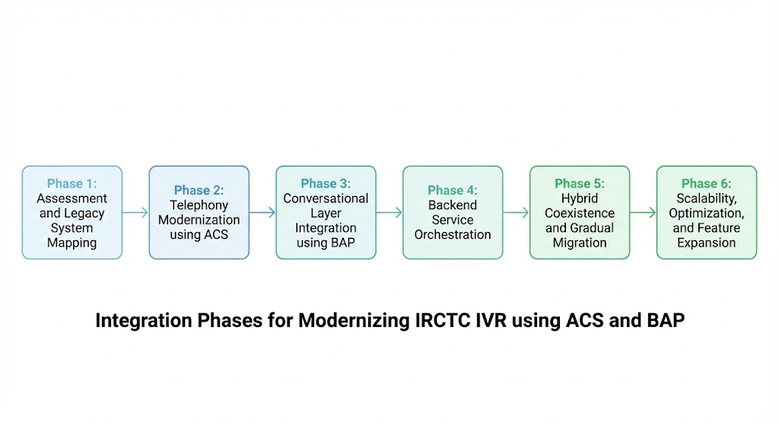

**13. Scalability & Feature Expansion for IRCTC**

## 13.1 Cloud-Based Horizontal Scaling

Traditional IVR systems operate on fixed infrastructure, which restricts their ability to handle sudden increases in call volume. In the modern architecture, **Azure Communication Services** enables horizontal scaling by dynamically allocating resources based on real-time demand.

This allows:

* Automatic scaling of call-handling and media-processing instances
* Support for thousands of concurrent calls
* No manual provisioning during traffic spikes

As a result, the IRCTC IVR remains responsive even under extreme load conditions.

## 13.2 Load Handling During Peak Booking Hours

IRCTC experiences peak traffic during Tatkal booking windows, festival seasons, and emergency situations. The conversational IVR architecture distributes incoming calls across multiple service instances and regions.

Key benefits include:

* Reduced call waiting time
* Efficient handling of repetitive queries through automation
* Lower dependency on human agents
* Consistent service availability during peak hours

This ensures uninterrupted passenger support during critical periods.

**13.3 Fault Tolerance and High Availability:**

Fault tolerance and high availability are essential for public-facing platforms such as IRCTC, where service interruptions can impact millions of users. A modern IVR system is therefore designed with resilience as a core architectural principle, ensuring that services remain accessible even during partial failures or peak operational stress.

To achieve this, multiple layers of redundancy and monitoring are incorporated across the IVR ecosystem. Communication services, conversational logic, and backend integrations are all designed to handle failures gracefully without disrupting the user experience. Key fault-tolerant mechanisms typically include:

* Automatic failover for telephony and conversational services to backup instances
* Session recovery to resume interactions after transient failures
* Graceful fallback to the legacy IVR system or escalation to live agents when required
* Continuous health monitoring and alerting for proactive issue detection

## ****13.4 Adding New Features Easily:****

One of the key benefits of conversational IVR modernization for **IRCTC** is the ease with which new services and capabilities can be introduced. Unlike traditional IVRs, where even minor changes require restructuring menus and call flows, conversational IVRs allow feature expansion at the conversational layer itself.

In this approach, new services are added by defining **new intents** rather than modifying rigid IVR menus. The core call flow remains unchanged, while the system becomes smarter in understanding user requests. Typical examples of such easily added features include:

* Special train or festival-specific announcements
* Updates related to railway policies and travel rules
* Introduction of new customer support or enquiry services

This flexibility significantly reduces development effort, shortens deployment cycles, and allows IRCTC to respond quickly to changing passenger needs.

## ****13.5 Addition of New Languages:****

India’s linguistic diversity makes multilingual support a critical requirement for railway enquiry systems. Traditional IVRs depend heavily on pre-recorded voice prompts, making the addition of new languages slow and resource-intensive. Conversational IVRs overcome this limitation by relying on speech and language models instead of static recordings.

By training language models for new languages, the system can support linguistic expansion with minimal changes to the underlying IVR logic. This approach enables:

* Faster rollout of regional and local languages
* Improved accessibility for rural and non-English-speaking users
* Better recognition of accents, dialects, and natural speech variations

## 13.6 Personalization Support:

Modern IVR systems enable a more personalized user experience by leveraging contextual information and historical interaction data. Unlike traditional menu-driven IVRs, which treat every caller as a new and identical user, conversational IVRs can adapt responses based on past interactions, current journey details, and user preferences. This approach makes interactions faster, more relevant, and less repetitive for passengers.

Personalization in an IRCTC IVR context can be implemented in a controlled and privacy-aware manner, focusing primarily on service efficiency rather than deep user profiling. Typical personalization capabilities may include:

* Remembering recent PNR enquiries to avoid repeated number entry
* Providing journey-specific updates such as delays or platform changes
* Offering context-aware follow-up responses based on the current call flow

By reducing redundant inputs and aligning responses with the user’s immediate needs, personalization significantly improves user satisfaction. It also helps in lowering average call duration and system load, which is particularly important for high-traffic public services like railway enquiry systems.

## 13.7 Proactive Alerts and Notifications:

Unlike traditional IVRs, modern conversational systems can proactively communicate with users **Proactive Alerts and Notifications**

Unlike traditional IVR systems that respond only after a user initiates a call, modern conversational IVR platforms enable **proactive communication** with passengers. This capability allows the system to deliver timely and relevant information without requiring users to navigate menus or repeatedly contact customer support.

In the context of railway services, proactive alerts significantly improve passenger experience by reducing uncertainty and enhancing trust. Instead of waiting for passengers to enquire about disruptions or changes, the IVR system can automatically notify users based on real-time backend updates and predefined trigger conditions.

Typical proactive alert use cases include:

* Train delay or cancellation notifications
* Platform change or rescheduling alerts
* Refund and transaction status updates
* Emergency announcements or major service disruptions

By enabling such notifications, the IVR evolves from a **reactive enquiry system** into an **intelligent passenger communication channel**. This shift not only reduces inbound call volume during peak disruption periods but also ensures that critical information reaches passengers in a timely and accessible manner, even for users without smartphones or internet access.

TASK 3: Technical Challenges, Constraints & Compatibility Gaps

**14. Development Challenges in IRCTC IVR Modernization**

## 14.1 Legacy System Complexity:

The existing IRCTC IVR system is built on VoiceXML (VXML) and follows a rigid menu-driven architecture, which was originally designed for deterministic and predictable call flows. Over time, incremental enhancements, multiple service additions, and interdependent call routing logic have caused the system to evolve into a highly complex structure with deeply nested menus and logic paths.

Key challenges in handling legacy complexity include:

* Understanding deeply nested and interdependent call flows, which may involve multiple layers of menu options and backend API calls.
* Mapping fixed menu selections to dynamic conversational intents, ensuring that the system correctly interprets user queries across multiple contexts.
* Preventing regression in existing services, as even minor changes in call flows can affect critical features such as PNR enquiry, train running status, or booking updates.

## 14.2 Limited Access to Production Systems:

Another major challenge is the restricted access to the live IRCTC IVR environment and backend APIs. For security and operational reasons, external developers cannot directly access production systems, making real-world testing nearly impossible.  
They introduce constraints in terms of:

* Accuracy: Mock services may not fully capture network latency, concurrency, or unexpected API responses, which could occur during real-world usage.
* Validation: Testing new conversational flows against a simulated backend may fail to reveal subtle errors that would only manifest in the production environment.
* Dependency: Development teams are constrained by the fidelity of simulation; incorrect assumptions can lead to integration issues during deployment.

## 14.3 Skill and Tooling Constraints:

IVR modernization at IRCTC requires a hybrid expertise spanning both legacy IVR systems and modern conversational AI platforms. Managing these two domains simultaneously is technically demanding and increases overall project complexity.

Specific skill and tooling challenges include:

* Dual Expertise Requirement: Developers need to understand VXML logic, DTMF-based navigation, and backend API integration while also being proficient in natural language understanding, intent detection, and context management in platforms such as ACS and BAP.
* Integration Complexity: Introducing a conversational layer on top of a legacy system requires careful design of adapter or middleware layers that can translate between deterministic menu-driven calls and probabilistic, free-form user inputs.
* Tooling and Testing: Hybrid systems demand advanced simulation, monitoring, and debugging tools to test both legacy and modern components together. Without proper tooling, identifying bugs or performance bottlenecks becomes challenging..

**15. Integration Challenges (Traditional IVR + ACS + BAP)**

## 15.1 Bridging Menu-Based IVR with Conversational Logic:

Traditional IVR systems operate on **deterministic logic**, where users navigate through predefined menu options using DTMF input. In contrast, modern conversational systems are designed to interpret **probabilistic, free-form speech**, allowing users to interact naturally. Reconciling these two paradigms is one of the most critical integration challenges in the IRCTC context.

To address this, an **adapter layer** is required that can translate conversational intents into legacy VXML actions. This layer ensures that user requests are correctly mapped to existing menu logic without disrupting current operations. Additionally, **robust fallback mechanisms** must be implemented to handle ambiguous or unclear user inputs, providing alternative prompts or guiding the user back to a safe state in the IVR flow.

Key integration mechanisms include:

* Adapter layer for intent-to-VXML mapping
* Fallback handling for ambiguous or unrecognized inputs
* Preservation of existing call flow logic during conversational transitions

## 15.2 Real-Time Data Synchronization:

IRCTC services such as **PNR status checks** and **train running updates** rely on backend systems that are highly dynamic and time-sensitive. Any delays or inconsistencies in data retrieval can significantly affect the user experience.

The integration must ensure that **real-time data** is synchronized between the conversational layer and legacy IVR services. Critical concerns include:

* **Latency management** to prevent long wait times during calls
* **API response failure handling**, ensuring the system can gracefully recover or provide fallback messages if backend services are temporarily unavailable

## 15.3 Conversational Context Management:

A key advantage of modern IVRs is their ability to support **multi-turn conversations**, where users can provide partial information or interact across multiple steps. Integrating this with a legacy menu-driven system requires careful **context management**.

Challenges in maintaining conversational context include:

* Preserving user context across multiple turns without breaking deterministic menu flows
* Ensuring seamless continuation between the modern conversational layer and legacy VXML call flows
* Handling partial or ambiguous user inputs while keeping backend queries accurate

## 15.4 High Call Volume Risks:

IRCTC experiences extremely high call traffic during **Tatkal booking hours**, festive seasons, and other peak travel periods. Without proper system scalability and load management, high traffic can cause:

* Call queuing delays
* Service degradation or downtime
* Increased user frustration due to longer response times

Ensuring **horizontal scalability**, load balancing, and fault-tolerant architecture is essential to maintain a smooth experience for millions of daily users.

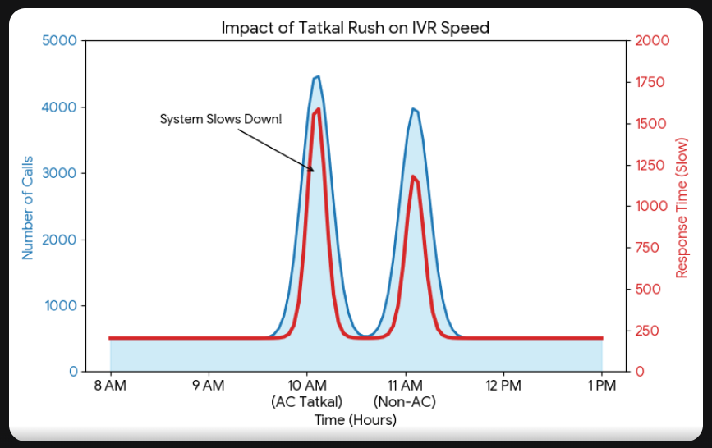

**16. Rationale Behind the Selected IRCTC IVR Features**

|  |  |  |
| --- | --- | --- |
| Feature | Decision | Rationale (Frequency, Risk, Automation) |
| PNR Status | ✅ **Chosen** | **High Freq / Low Risk:** The #1 query. Simple database lookup perfect for AI automation. |
| Train Status | ✅ **Chosen** | **High Freq / Low Risk:** "Where is my train?" is a standard, repetitive query easily served via API. |
| Seat Availability | ✅ **Chosen** | **High Freq / Med Risk:** Critical for planning. Structured inputs (Station, Date, Class) map well to voice. |
| Booking Confirmation | ✅ **Chosen** | **Med Freq / Low Risk:** Post-booking anxiety check ("Did I get the ticket?"). Read-only and fast. |
| Payment Disputes | ❌ **Excluded** | **Low Freq / High Risk:** Requires complex investigation, evidence verification, and human judgment. |
| Profile/Account Edits | ❌ **Excluded** | **Low Freq / High Risk:** Hard to capture addresses/email over voice accurately; security risks are too high. |
| Complex Route Planning | ❌ **Excluded** | **Low Freq / High Complexity:** Multi-leg journeys are too confusing to narrate over voice; better suited for screens. |

## 

**17. Architectural and Security Constraints**

## 17.1 Data Sensitivity:

**Key measures include:**

* **Data Encryption:** All data, both in transit and at rest, should be encrypted using robust algorithms like AES-256. This prevents unauthorized access even if storage systems or communication channels are compromised.
* **Secure API Access:** Backend APIs must require authenticated access using **token-based security**, ensuring only authorized components or services can query sensitive data.
* **Restricted Logging:** Logs are essential for debugging and auditing but should **never store raw PNR numbers or personal information**. Sensitive identifiers should be masked or anonymiszed to prevent accidental data exposure.

## 17.2 Compliance and Architectural Constraints:

**Mandatory constraints include:**

* **Government Compliance:** The system must adhere to Indian government data protection and auditability policies for public services.
* **Zero or Minimal Downtime:** IVR availability is critical, particularly during Tatkal booking periods. Any downtime can severely affect user trust and revenue.
* **Backward Compatibility:** New conversational features must integrate **without disrupting existing menus and call flows**, ensuring ongoing services remain reliable and consistent.

These constraints demand a **hybrid modernization approach**, layering conversational intelligence on top of the existing architecture without compromising operational stability

**18. ACS and BAP: Why Their Features Are Essential**

## 18.1 Azure Communication Services (ACS):

ACS is a cloud-based platform designed to handle **enterprise-grade communication**. Its role in the IRCTC IVR modernization is primarily to **ensure reliable call handling and high availability**, which is crucial for a public-facing system serving millions of users.

**Key benefits of ACS include:**

* **Scalable Call Handling:** ACS allows the system to handle **high call volumes**, including Tatkal and festive surges, without performance degradation. It supports **dynamic scaling**, so resources automatically adjust based on traffic.
* **Reliable Speech-to-Text and Text-to-Speech:** ACS provides enterprise-grade speech services, enabling accurate **voice recognition** and **audio response generation**. This ensures that users can interact with the IVR naturally, even in multilingual or noisy environments.
* **Redundancy and Fault Tolerance:** ACS infrastructure supports **automatic failover** and distributed communication channels, reducing the risk of system downtime during peak operations.

## 18.2 Bot Application Platforms (BAP):

BAP acts as the **intelligent conversational layer** on top of the legacy IVR system. It brings **AI-driven dialogue management** and **intent recognition** capabilities that traditional IVRs cannot provide.

**Critical functionalities of BAP include:**

* **Intent Recognition:** BAP can interpret **free-form user queries**, mapping them to predefined intents like PNR status, train availability, or cancellation requests. This allows the IVR to handle **natural language input** instead of rigid keypad inputs.
* **Context Tracking:** Modern conversational systems require **multi-turn dialogue management**, remembering user input across multiple interactions. BAP ensures context is preserved, so the system can respond appropriately without forcing users to repeat information.
* **Dialog Orchestration:** BAP manages complex conversational flows, ensuring that **user queries are handled logically**, fallback mechanisms are triggered when needed, and interactions are seamless even when integrating with legacy VXML menus.

## 18.3 Combined Impact of ACS and BAP:

By integrating ACS and BAP, the IRCTC IVR modernization achieves **both operational reliability and conversational intelligence**:

* **Operational Reliability (ACS):** Ensures calls are handled efficiently and speech services remain accurate, even under high load.
* **Conversational Intelligence (BAP):** Allows natural, multi-turn, context-aware dialogues, reducing user effort and improving satisfaction.

**19. Compatibility and Feature Gaps**

## ****19.1 Limitations of Traditional IVR Systems:****

* **Absence of Natural Language Understanding (NLU):**  
  Users cannot speak freely; the system only reacts to **keypad inputs or specific voice commands**. Complex queries like “Show me trains with available seats from Delhi to Mumbai after 6 PM” cannot be understood without explicit menu navigation.
* **No Multi-turn Context Management:**  
  Each menu option is independent. Users must re-enter information if switching between services or if interruptions occur, leading to repetitive and frustrating experiences.
* **Limited Personalization:**  
  Legacy IVRs do not retain user history. Regular travelers cannot benefit from previously entered PNRs or preferred language settings. Each interaction is **one-size-fits-all**.
* **High Maintenance and Low Scalability:**  
  Adding new features requires **rewriting menu structures** and VXML scripts. This slows down deployment and increases the risk of errors in other parts of the IVR.
* **Poor Handling of Ambiguities:**  
  Traditional IVRs cannot handle **unclear or partial inputs**. If the user presses the wrong key or pronounces something incorrectly, the system either fails or returns to the main menu.

## ****19.2 Limitations of Modern IVR Systems:****

* **Speech Recognition Imperfections:**  
  Accuracy is affected by accents, background noise, dialects, and code-mixed language (e.g., Hindi-English). Misinterpretation of queries can frustrate users.
* **Handling Highly Complex Queries:**  
  Complex requests, such as multi-leg journeys or combined PNR and seat change queries, may require **human intervention**. Full automation in these scenarios is not yet feasible.
* **Dependency on Cloud Services:**  
  Modern IVRs rely on cloud-based APIs (speech-to-text, intent recognition). Network latency or downtime can **degrade performance**, especially during peak hours.
* **Data Privacy and Security Risks:**  
  Storing and processing conversation data introduces concerns over **user privacy, regulatory compliance, and secure access**.
* **Multi-turn Dialog Challenges:**  
  Maintaining context over long conversations or switching topics mid-dialogue can still be error-prone, especially if the AI is not properly trained for all scenarios.

## ****19.3 Summary of Compatibility Gaps:****

|  |  |  |  |
| --- | --- | --- | --- |
| Aspect | Traditional IVR | Modern IVR | Gap / Challenge |
| Input Type | Keypad / fixed commands | Free-form speech | Need adapter for deterministic + probabilistic input |
| Context Awareness | None | Partial | Multi-turn dialogues still prone to errors |
| Personalization | None | Basic | Limited history-based responses |
| Error Handling | Menu restart | AI fall-back | Misinterpretation possible; human escalation needed |
| Analytics | Minimal | Moderate | Insight-driven improvements possible but dependent on AI logs |
| Scalability | Hardware-dependent | Cloud-enabled | Dependent on network and cloud performance |

**20. Future Enhancements and Improvement Opportunities**

**Potential Future Enhancements**

1. **AI-Driven Call Analytics**  
   Modern analytics can provide deep insights into **frequent user issues, query patterns, and interaction bottlenecks**.  
   Benefits include:
   * Identification of **common pain points** in existing IVR flows
   * Optimization of conversational prompts and menu structures
   * Data-driven improvements for both automation and live agent support
   * Real-time monitoring of call quality and user sentiment
2. **Enhanced User Personalization**  
   Using historical interactions and stored preferences, the IVR can **adapt responses** to each individual user:
   * Remembering recent PNR enquiries to reduce repetitive input
   * Suggesting commonly traveled routes or preferred language settings
   * Providing personalized follow-up questions based on past queries
3. **Predictive Assistance for Travel-Related Queries**  
   AI models can **anticipate user needs** and proactively provide relevant information:
   * Predicting train occupancy trends or seat availability based on historical patterns
   * Suggesting alternative trains or routes in case of full bookings
   * Offering reminders for upcoming travel or seasonal ticket windows
4. **Proactive Alerts and Notifications**  
   Beyond reactive responses, the IVR can actively communicate critical updates to users:
   * Train delays, cancellations, and rescheduling notifications
   * Platform changes or boarding alerts
   * Refund status updates or service disruption announcements  
     These features **enhance passenger convenience** and reduce the need for repetitive inbound calls, making the system more **user-centric**.
5. **Incremental Feature Deployment**  
   Since the hybrid architecture **does not require changing the legacy IVR**, new functionalities can be deployed gradually:
   * Testing new AI models in parallel before full integration
   * Rolling out predictive or personalized features in a phased manner
   * Ensuring backward compatibility so existing users are not affected

**21. Risk Handling and Data Protection Measures**

## ****Data Leakage Prevention:****

Data leakage is a critical concern for passenger-focused systems. The IRCTC IVR must ensure that **personal identifiers, booking details, and travel history** are never inadvertently exposed or retained longer than necessary.

## ****Failure Handling and Recovery:****

Even with secure systems, **operational failures are inevitable**—whether due to network issues, API timeouts, or unexpected user inputs. Ensuring that the user experience remains uninterrupted is crucial for trust and system reliability.

## 

This flowchart depicts the system's resilience strategy. If an error occurs during an IVR operation, the system first attempts a retry. If the error persists after a maximum number of retries, it executes a fallback plan. Depending on the nature of the failure, the call is routed either to a legacy IVR system for basic continuity or to a human agent for complex issues, ensuring the user's needs are still met.